**ABSTRACT**

A recommender system, a subclass of information filtering systems, aims to predict the rating or the preference a user might give to an item. Based on this prediction, it would suggest relevant items to the users, making their experience more personalized and enjoyable. For example, in the case of Netflix, it would suggest movies; in the case of kindle, it would be books. In this project, we worked with MovieLens dataset, then proceeded for building two types of recommender systems: content and item based collaborative system. The former system recommends relevant movies to the users by using content of the previously searched items that the user likes, while the later one deals with finding similar movies using SVD model. Here, content refers to the attribute of the movie, that is genre. At the end of the work, evaluation parameters have been incorporated in the systems, achieving 0.65 in average MAP,0.865 in average NDCG, while a score of 0.6410 and 0.4968 has been seen respectively in RMSE and MAE.

**WHAT OTHERS HAVE DONE**

1. The user/item specific information is grouped to form a cluster using K-means clustering
2. Bayesian belief nets CF (collaborative filtering) was implemented
3. Some have used MDP based CF for improving predictions
4. Matrix factorizations on CF has been performed

**LIMITATIONS**

1. With an increase in the number of users and movies, the computational time of the system increases.
2. Model building is expensive in case of Bayesian belief nets
3. There is trade-off between prediction performance and scalability
4. Lose useful information since only user id and movie id is used to create the embeddings

**METHODOLOGY**

i)Flowchart:

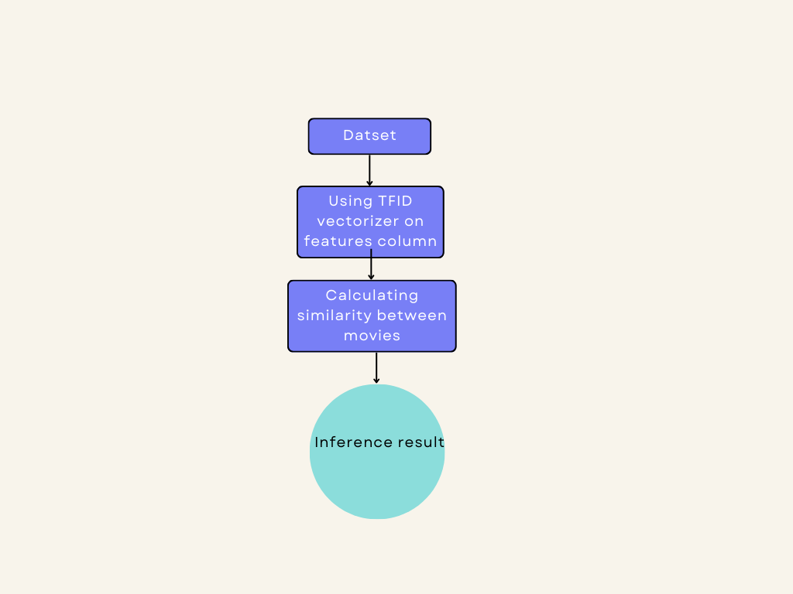

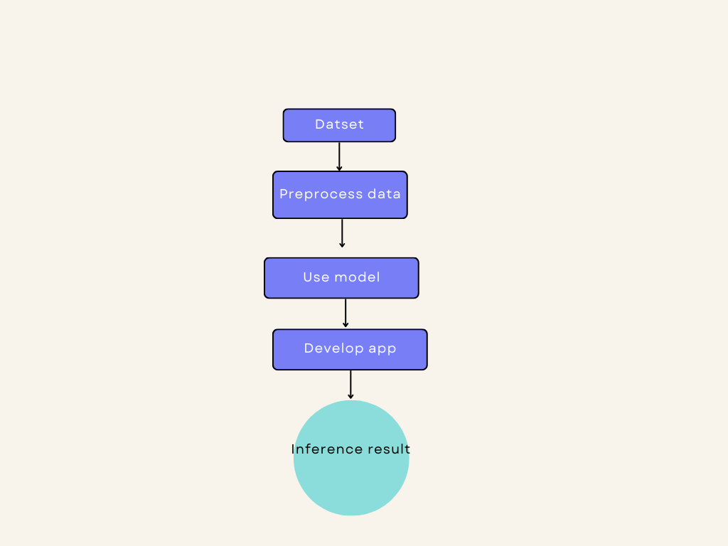

ii)Dataset:

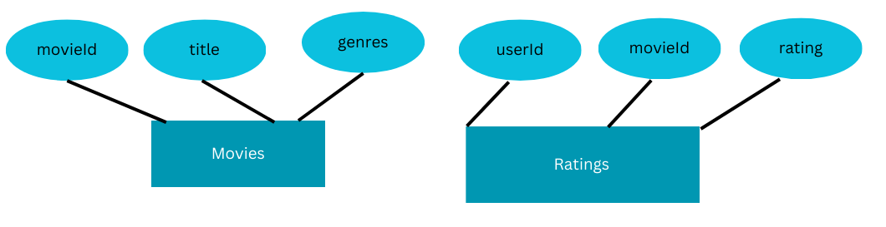

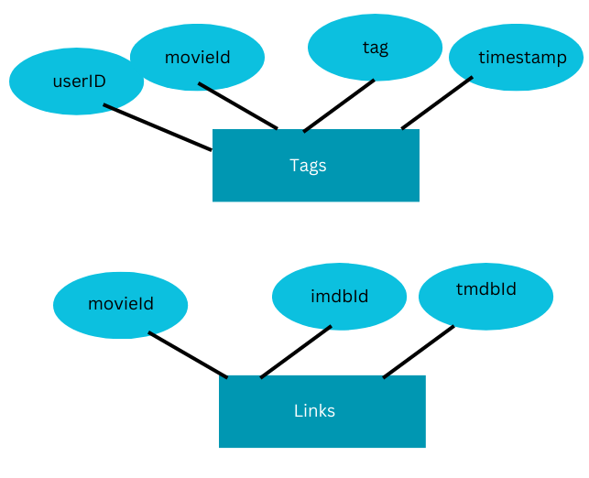

iv) Programming languages: Python(for ml), Flask(for web application), HTML and CSS(for frontend)

v) App:

